ACEC No: | Cage#: |  |  |  | Animal ID:
Researcher / Trainer: | Species/Strain: |  |  |  | Sex/Age:
Phone: | Date performed:
Email: | Procedure:
Day post-procedure: | Day x | Day x | Day x | Day x |  | Day x | Day x | Day x | Day x
Date of monitoring:
CLINICAL OBSERVATION - UNDISTURBED
Activity: normal = 0; isolated = 1; huddled/inactive = 2; moribund/fitting = 3
Posture: normal = 0; hunched = 2; trembling = 3
Movement/gait: normal = 0; slight incoordination = 1; tiptoe walking or reluctance to move = 2; staggering/limb dragging/paralysis = 3
Coat condition: normal/groomed = 0; rough = 1; ruffled/unkempt = 2; bleeding or infected wounds or self-mutilation = 3
Eating/drinking: normal = 0; decreased intake during the 1st 24 hrs day = 1; decreased intake more than 1 day = 2; decreased intake over 48hrs = 3
Breathing normal = 0; rapid, shallow = 1; rapid, abdominal breathing = 2; laboured, irregular, skin blue = 3
CLINICAL OBSERVATION - ON HANDLING
Alertness: normal = 0; dull or depressed = 1; little response to handling = 2; unconscious = 3
Body weight: (gm / score)  normal weight & growth rate = 0; reduced growth weight = 1; chronic weight loss>15% = 2; weight loss = or >20% = 3 | g
Body Condition Score:¹ score 3-5 = 0; score 2 = 2; score 1 = 3
Dehydration: none=0; skin less elastic=1; skin tenting=2; skin tenting & sunken eyes=3
Eyes, nose: normal=0; wetness or dull eyes=1; discharge/squinty eyes=2; coagulated nasal discharge/matted eyes=3
Faeces: normal=0; moist but formed=1; loose, soiled peri-anal area or mucoid=2; watery or no faeces for 48hrs or blood=3
Urination: normal = 0; increased urination (wet bedding) = 2
SPECIFIC TUMOUR MONITORING (EXTERNAL TUMOURS)
Tumour by palpation: tumour present Y or N
Tumour size (length):²

Tumour size (width):²

Tumour interference with mobility
Normal = 0; impeding on normal mobility or behaviour = 3

Subcutaneous tumour ulceration scoring (use figure 2 below)
% Tumour surface area ulcerated: refer to figure 2
Maximum ulceration depth: refer to figure 2
Ulcer appearance and discharge refer to figure 2
Surrounding skin condition: refer to figure 2
OTHER OBSERVATIONS AND NOTES
Body temperature:³ (basal t 0 = 0; 1 ⁰C ↓= 1; 2 ⁰C ↓= 2, >3 ⁰C ↓ = 3)
Facial Grimace Score⁴ (Absent = 0; present = 2)

Other abnormalities (describe):

Treatment/support: (e.g., analgesic, fluids, antibiotics, mushy food, hydrating gels, etc.)
Other comments:

Monitored by:

- Body condition score is a useful tool in presence of tumours that may mask weight loss
- Increased monitoring when tumour size is nearing humane endpoint criteria
- Body temperature measurement is optional but can be useful as an adjunctive tool for euthanasia
- Facial grimace scoring is optional and can be a useful tool for enhanced monitoring of welfare
Increased monitoring and immediate veterinary intervention required if a score of 2 is recorded for any individual clinical observations listed above or presence of ‘other abnormalities’.

Immediate euthanasia is required if a score of 3 is recorded for any individual clinical observation as listed above or animal is not responsive to veterinary intervention.
Figure 1. Body condition scoring figure from Ullman-Culleré and Foltz (1999)
Figure 2 Tumour monitoring assessment adapted from https://animalcare.ubc.ca/sites/default/files/documents/Tumour%20Ulceration%20Guideline%202018%20final.pdf

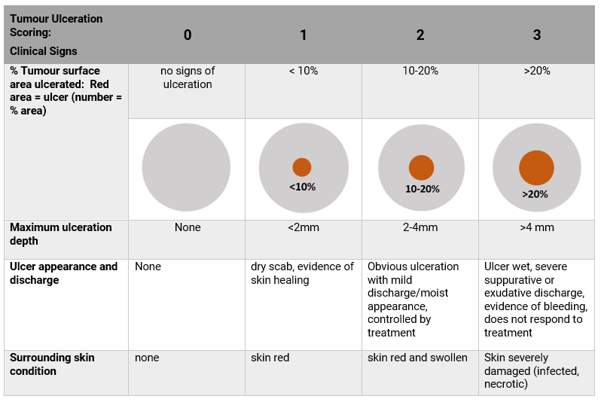
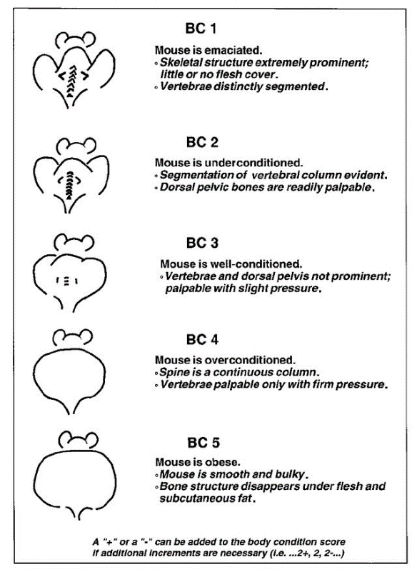

Figure 3 The mouse grimace scale from N3CRs (https://nc3rs.org.uk/grimacescales)
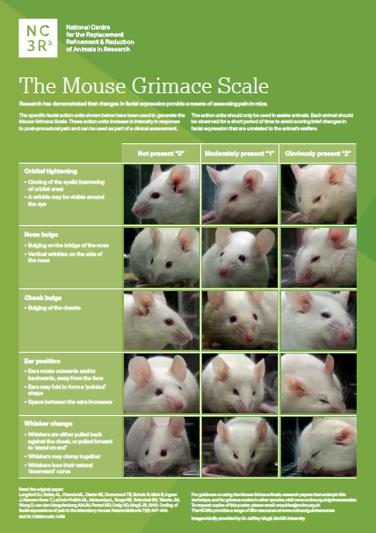

REFERENCES
- https://animalcare.ubc.ca/sites/default/files/documents/Tumour%20Ulceration%20Guideline%202018%20final.pdf
- http://www.dpi.vic.gov.au/agriculture/about-agriculture/legislation-regulation/animal-welfare-legislation/codes-of-practice-animal-welfare/care-of-laboratory-mice-rats-guinea-pigs-rabbits
- Olfert, E., Bhasin, J., Latt, R., McCutcheon, K., Rainnie, D., & Schunk, M. (1998). CCAC Guidelines On: Choosing an Appropriate Endpoint in Experiments Using Animals for Research, Teaching and Testing.
- Jensen, M. M., Jørgensen, J. T., Binderup, T., & Kjaer, A. (2008). Tumor volume in subcutaneous mouse xenografts measured by microCT is more accurate and reproducible than determined by 18F-FDG-microPET or external caliper. BMC medical imaging, 8, 16. https://doi.org/10.1186/1471-2342-8-16
- Morton D. B. (2000). A systematic approach for establishing humane endpoints. ILAR journal, 41(2), 80–86. https://doi.org/10.1093/ilar.41.2.80
- Morton, D. B., & Griffiths, P. H. (1985). Guidelines on the recognition of pain, distress and discomfort in experimental animals and an hypothesis for assessment. The Veterinary record, 116(16), 431–436. https://doi.org/10.1136/vr.116.16.431
- Grimace scales https://nc3rs.org.uk/grimacescales
- Faustino-Rocha, A., Oliveira, P. A., Pinho-Oliveira, J., Teixeira-Guedes, C., Soares-Maia, R., da Costa, R. G., Colaço, B., Pires, M. J., Colaço, J., Ferreira, R., & Ginja, M. (2013). Estimation of rat mammary tumor volume using caliper and ultrasonography measurements. Lab animal, 42(6), 217–224. https://doi.org/10.1038/laban.254
- Paster, E. V., Villines, K. A., & Hickman, D. L. (2009). Endpoints for mouse abdominal tumor models: refinement of current criteria. Comparative medicine, 59(3), 234–241.
- Ullman-Culleré, M. H., & Foltz, C. J. (1999). Body condition scoring: a rapid and accurate method for assessing health status in mice. Laboratory animal science, 49(3), 319–323.
- Wallace J. (2000). Humane endpoints and cancer research. ILAR journal, 41(2), 87–93. https://doi.org/10.1093/ilar.41.2.87
- Workman, P., Aboagye, E. O., Balkwill, F., Balmain, A., Bruder, G., Chaplin, D. J., Double, J. A., Everitt, J., Farningham, D. A., Glennie, M. J., Kelland, L. R., Robinson, V., Stratford, I. J., Tozer, G. M., Watson, S., Wedge, S. R., Eccles, S. A., & Committee of the National Cancer Research Institute (2010). Guidelines for the welfare and use of animals in cancer research. British journal of cancer, 102(11), 1555–1577. https://doi.org/10.1038/sj.bjc.6605642

